1) OUTPUT:
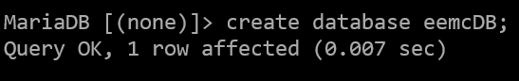
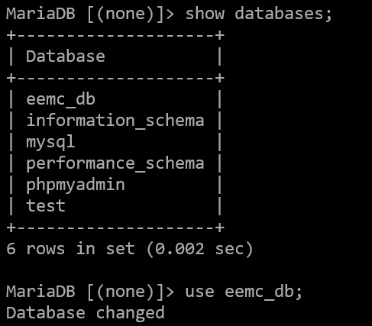
2) OUTPUT:
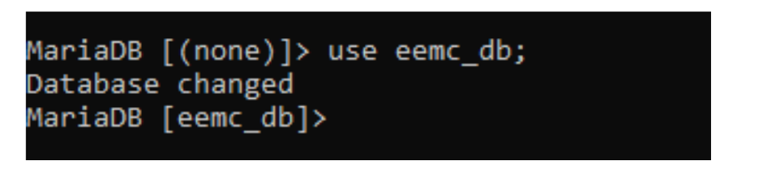
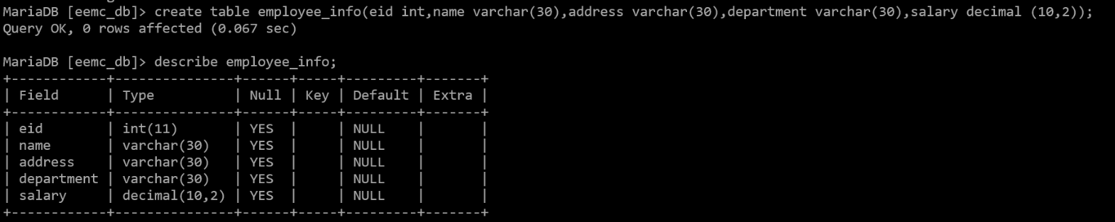
3) OUTPUT:
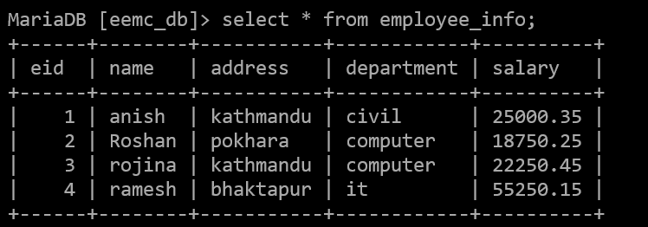
Now commit the transaction
commit ;
4) OUTPUT:
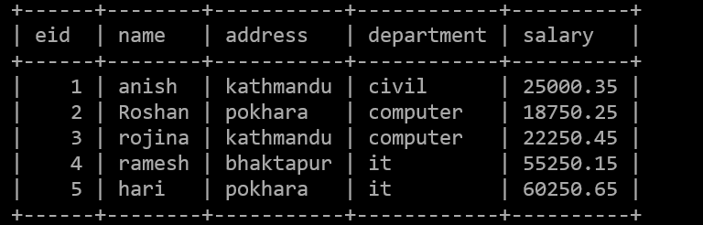
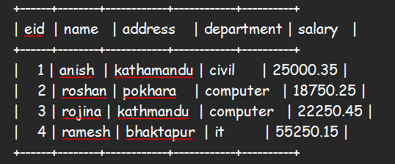
5) OUTPUT:

6) OUTPUT:
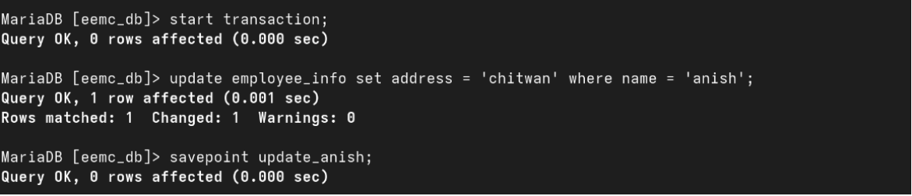
7) OUTPUT:
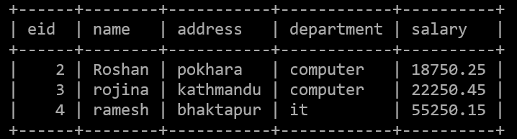
8) OUTPUT:
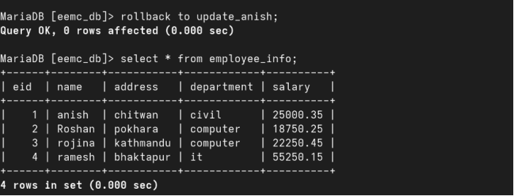
9) OUTPUT:
10) OUTPUT:
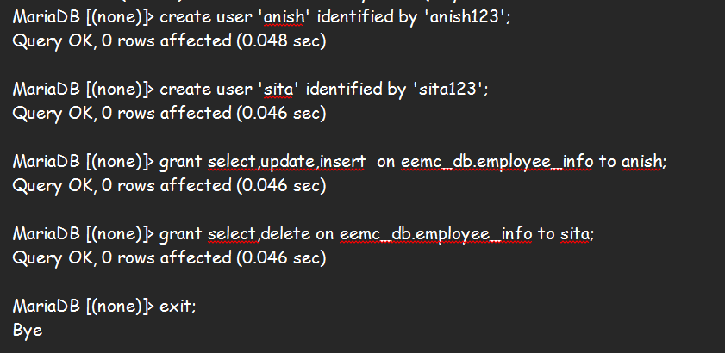
Reconnect mariadb server with user named anish
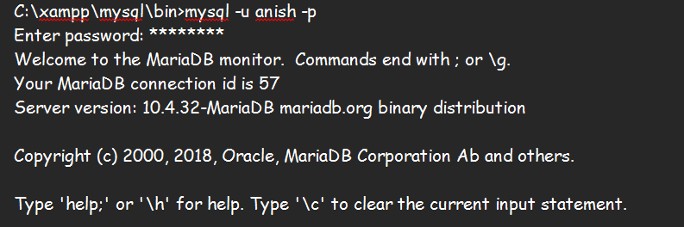
Now, try to perform the above operations that is given privilege to user anish
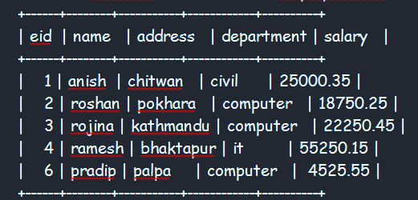
11) OUTPUT:
Now, switch to another user named sita
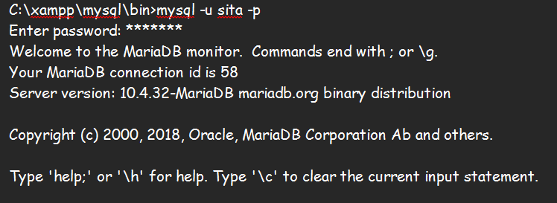

12)OUTPUT:
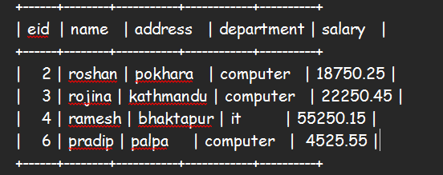
13) OUTPUT:
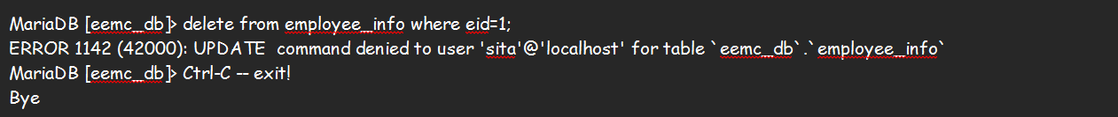
14) OUTPUT:
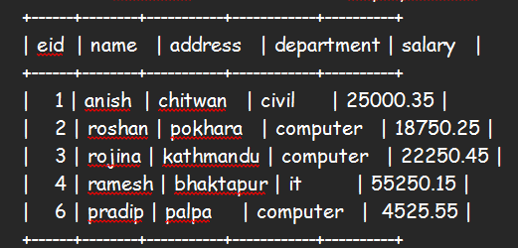
15. OUTPUT:
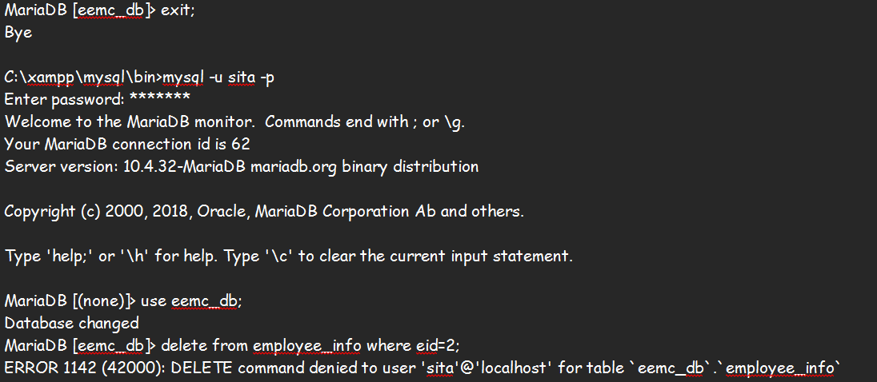
To list out all users
select user from mysql.user;
To find out which grant is given for particular user
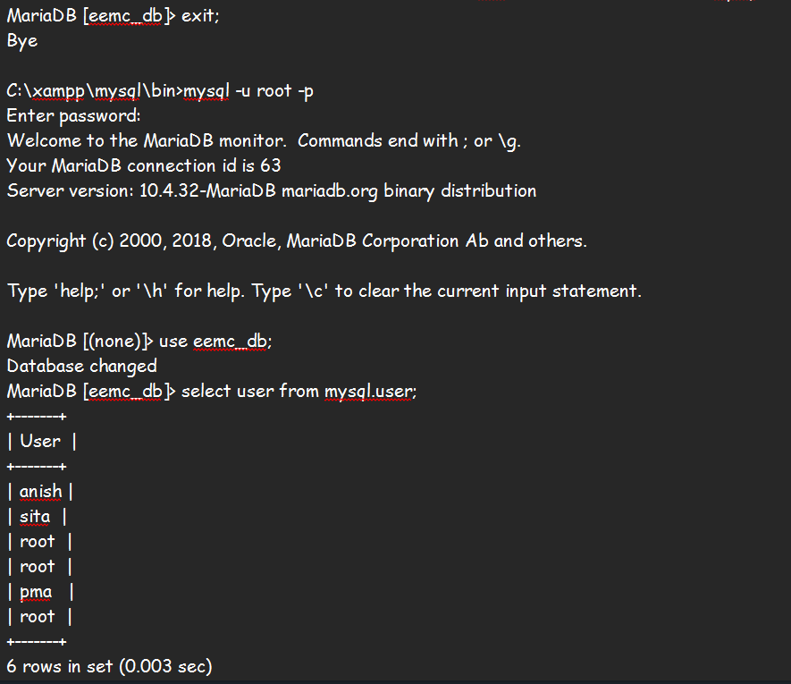
To find out which grant is given for particular user
